Top of Form
Dice Roll Animation Part 1
Bottom of Form
by Didik Wijaya
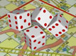In this tutorial I will show you how to create dice roll animation with ease. This tutorial is divided into 2 section. First, this section, you will create 3D dice model using quick techniques. Second, you will create the animation. Not only one dice, but as many as you want. Let's begin by creating 3D dice model.

1. Open or reset your 3dsmax. Go to Command Panel. Choose Extended Primitives from drop-down list. Click ChamferBox button. Then, click and drag in viewport to create ChamferBox. Next, go to Modify tab and enter values in image below. When finished, you get basic shape of a dice.
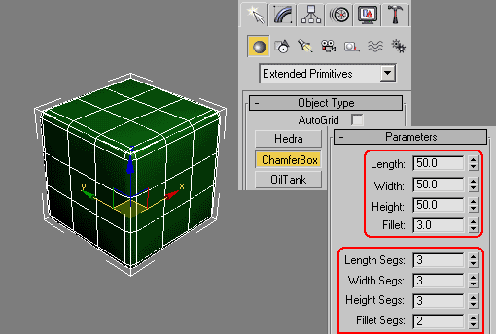

2.Right click ChamferBox and choose Convert to>Convert to Editable Poly. In Modify tab, activate Polygon selection. Select 4 polygons at one side of ChamferBox (hold Ctrl while clicking to select more than one polygon). After that, in Edit Polygons rollout click Settings button right next to Inset. In Inset Polygons dialog box, enter Inset Amount=3. Don't deselect anything. This time, click Settings button right next to Extrude. In Extrude Polygons dialog box, enter Extrusion Height=-2.
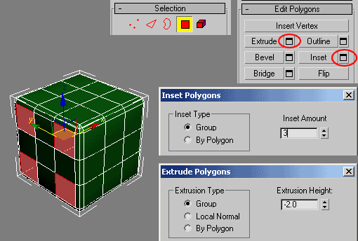

3. Next, select 2 polygons in the middle. Use the same value of Inset and Extrude. When finished, you get 6-dotted at one side of the dice.
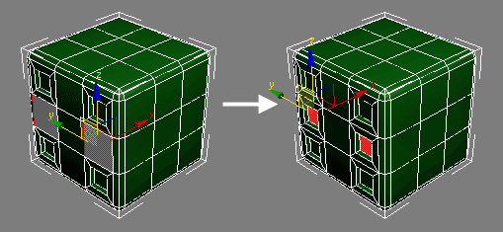

4. Using the same procedure, apply Inset and Extrude to all side of the dice. Tips: Having a real dice in front of you is helpful. You can easily know how many dotted needed in each side. If you don't have a real one, you can look at image below.
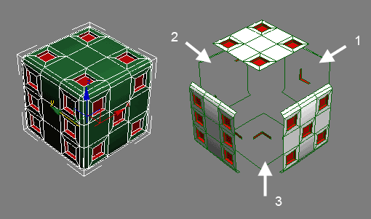

5. Next, select all extruded polygons in all sides. There are 21 polygons you need to select. As always, hold Ctrl while clicking to select more than one polygon. In Selection rollout, click Grow to add more selection. Then, in Polygon Properties rollout enter Set ID=2. By default, other polygons have ID=1. When finished, turn off Polygon selection.
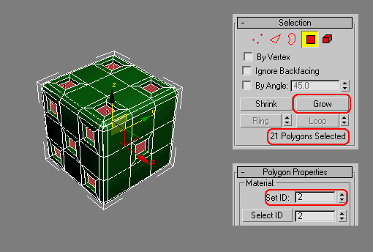

6. In this step, we are going to add material. Open Material Editor (press "M" in keyboard). By default, one of unused sample material slot is selected. Name this material "dice". Click Standard button to change material type. In Material/Map browser double click Multi/Sub-Object. In opened dialog box, just click OK. In Multi/Sub-Object Basic Parameters rollout click Set Number, enter 2 and click OK. You only need 2 sub material. Click button under Sub-Material (where ID=1). Name this sub-material "white" and change Diffuse color to white. Click Go to Parent button to go back to Multi/Sub-Object Basic Parameters rollout. Using the same procedure, change other sub-material name where ID=2 to "red". Use red Diffuse color. Click Go to Parent button. Finally, click and drag from sample slot to dice object in viewport to appy material.
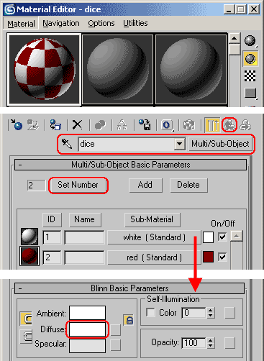

7. To finish this tutorial section, apply Turbosmooth modifier to dice object. Use Iterations value=2..
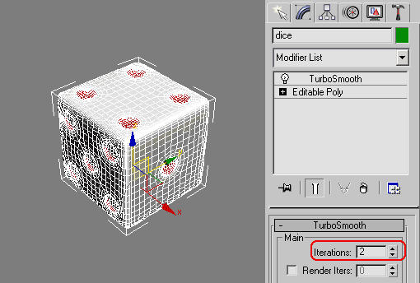

8. Image below shows rendered dice. Next, you will animate the dice.

