**Disable Xbox Controller on Windows 10**

1. Bring up Windows Settings dialog

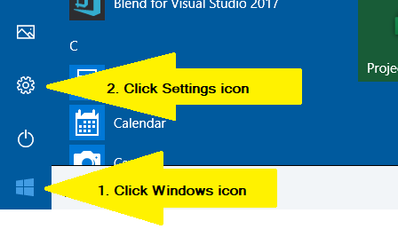

1. Select Gaming

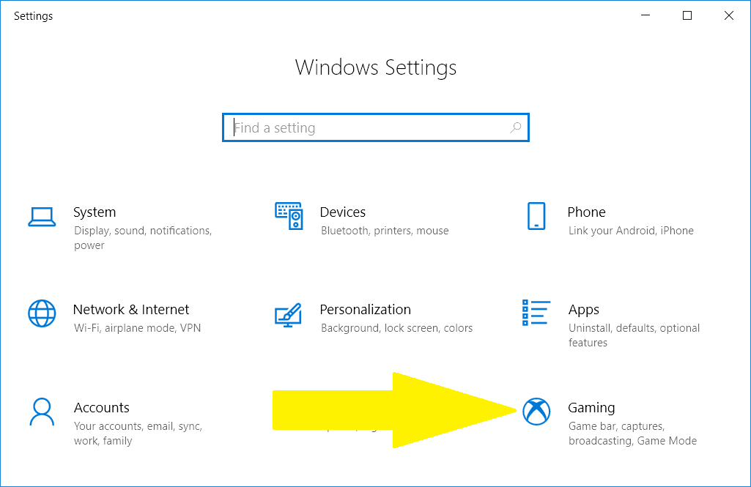

1. Disable Xbox button

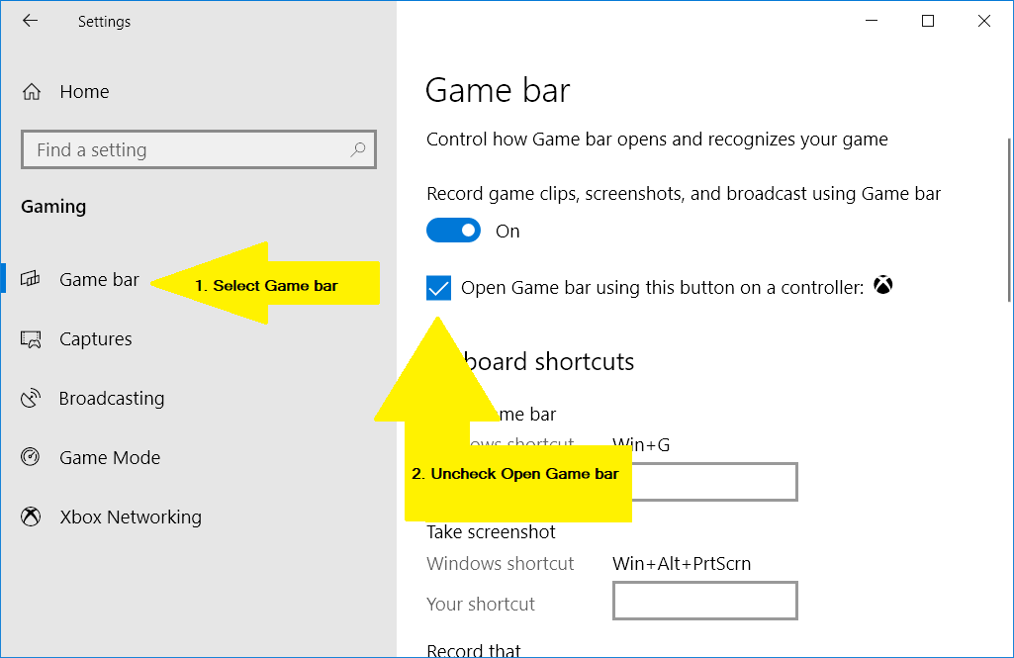

1. Turn off Game Mode

