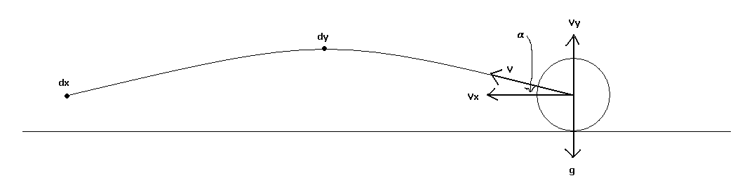
To trace the trajectory of a kicked ball given the velocity of the ball at the time of the kick and the angle of the kick, begin by replacing the ball with its center of gravity. The vector of the ball’s velocity v can then be broken into a horizontal component v_{x}, which remains constant (neglecting air resistance) due to Newton’s First Law, and a vertical component v_{y}, which is countered by the force of gravity, g, an acceleration of 9.8 m/s².
Therefore the velocity V_{y} at time t equals the original vertical velocity, V_{y}⁰, minus the acceleration due to gravity: V_{y} = V_{y}⁰ – gt . When the ball reaches its maximum height, its velocity is zero, and solving for t means that the ball is at its maximum height at t_{max} = V_{y}⁰ ÷ g .
The height of the ball d_{y} at time t is then equal to the distance traveled upward from the kick (the orginal vertical velocity times the time) minus the distance traveled downward due to the constant acceleration of gravity (via d = ½ at²): d_{y} = V_{y}⁰t – ½gt² . At the maximum height (time t_{max}), the height is therefore d_{ymax} = (V_{y}⁰ V_{y}⁰÷g) – ½g(V_{y}⁰ V_{y}⁰÷g) ²→ d_{ymax} = ½ (V_{y}⁰)² ÷ g .
At the end of the ball’s flight, d_{y} = 0; solving for t from the equation deriving d_{y} shows that the ball hits the ground again at t_{end} = 2V_{y}⁰ ÷ g . The horizontal distance d_{xmax} traveled at the end of the trajectory is therefore V_{x}t; thus d_{xmax} = 2V_{y}⁰V_{x} ÷ g .
It is now possible to calculate the maximum height and distance given the original angle and velocity applied to the ball. The calculation can now be reversed by solving the equations for V_{y}⁰ and V_{x}, it turns out that V_{y}⁰ = √(2gd_{y}) and V_{x} = gd_{x} ÷ 2V_{y}⁰ . From these it is possible to calculate the original angle α = atan(V_{y}⁰ ÷V_{x}) and the magnitude of the velocity |v| = √((V_{y}⁰)² + (V_{x})²) required to send a ball d_{y} high at maximum and d_{x} far.

It is now desirable to find the amount of force necessary to give the ball the required velocity. Given the assumption that the kicking mechanism uniformly accelerates the ball until it reaches the velocity V, the distance d the mechanism travels must equal ½ at²; the mechanism’s final velocity is V = at . The value of d is known, as the velocity, so solving for t in terms of d and V yields t = 2d ÷ V . Then substituting into the velocity equation and solving for a yields a = V² ÷ 2d . This is the acceleration given to the ball by the mechanism.
The mass of the ball m is also known, and using F = ma means that the force required to kick the ball d_{y} high at maximum and d_{x} far is mV² ÷ 2d , where m is the mass of the ball, V is the required velocity (derived in the previous section), and d is the stroke length of the kicking mechanism. (Note that the assumption that the kicking mechanism uniformly accelerates the ball may be an oversimplification.)

See sheet 2 of the Excel file.

P. Stoeckl

