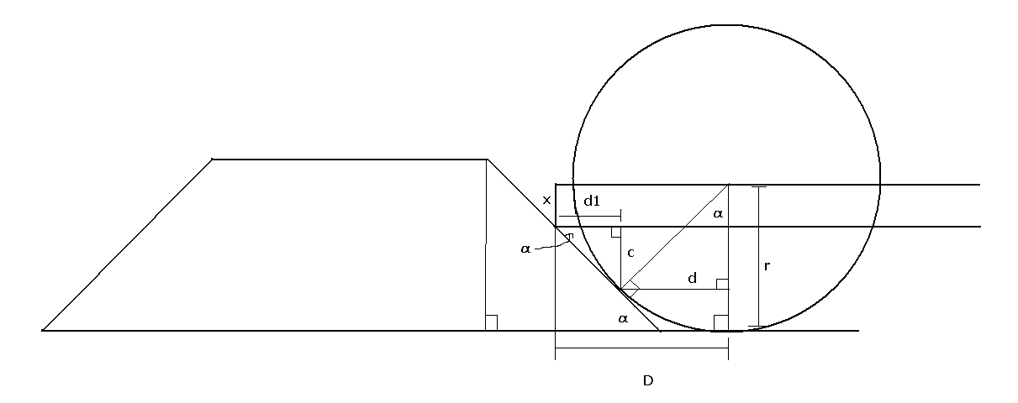
It can be shown that the ramp angle α is equal to the angle between the two radii shown. Given this angle and the radius r of the wheel, it is now possible to determine the horizontal distance d = r sin α from the wheel center to the point where the wheel touches the ramp. Given the extent of the chassis below the wheel center (x), it is now possible to calculate c = r cos α – x. It can also be shown that the third labeled angle is also equal to α. From this and c can be derived d₁ = c ÷ tan α. Finally, the maximum overhang of the chassis beyond the wheel center is equal to D = d + d₁.

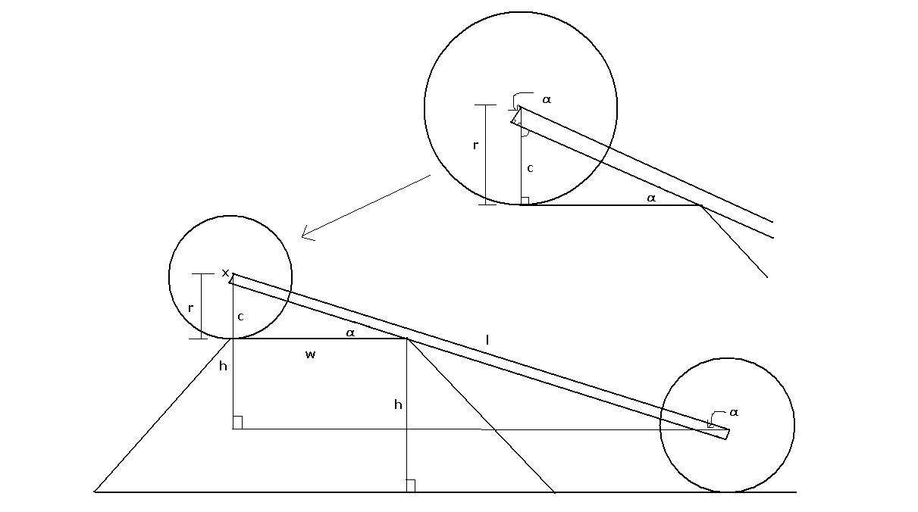
The above diagram illustrates the “worst-case scenario”. Given the height of the ramp h and the distance between wheel centers l, the angle α that the chassis makes with the horizontal can be calculated: α = asin h ÷ l. The top of the ramp is also horizontal; therefore the second labeled angle is also equal to α. From this and the width of the flat top of the ramp w can be calculated the distance c = w tan α. It can then be shown that both the angles labeled in the detail are equal to α, from which can be derived the maximum extent of the chassis below the wheel centers: x = (r – c) cos α.

See Sheet 1 of the Excel file. P. Stoeckl

